Chapter 11, Solution 82.

(a) 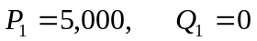

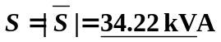

- Q = 17.171 kVAR

(c ) 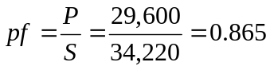

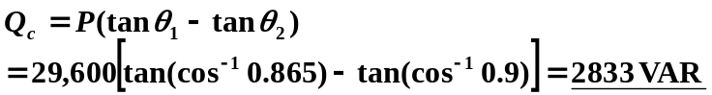

(c) 